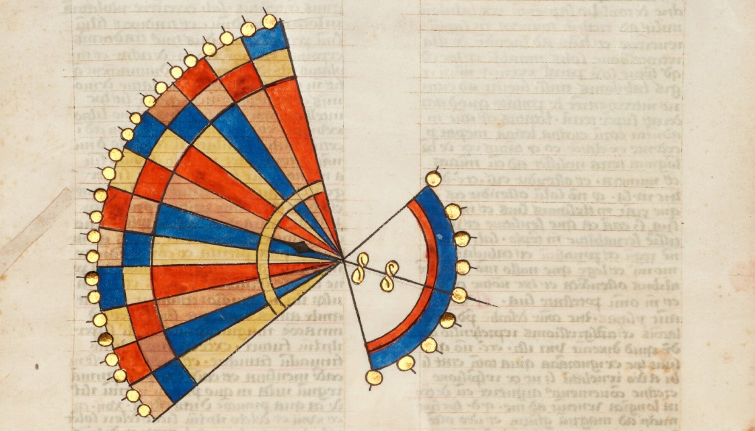
Lines, Flows, and Forms

The Forty-Eighth Annual Sewanee Medieval Colloquium
March 24-25, 2023
The University of the South, Sewanee, TN

‌

Call for Papers:
The Sewanee Medieval Colloquium invites papers exploring aspects of lines, flows, and forms in all aspects of medieval culture. We envision this theme to be capacious in its scope, and we imagine papers that might look at a range of topics. Approaches might include:

- the harmonic and the dissonant line in the Middle Ages
- medieval futurity
- queer and straight lines (broadly imagined)
- through-lines and genealogies
- flows and medieval ecology
- potential afterlives of medieval forms
- refrain and repetition
- the politics of perspective
- the ethics of historiography
- chronicles and timelines
- population flows and migration
- forms of law in the Middle Ages
- medieval forms of life
- scribal production and lines of script
- manuscript networks and acts of transcription
- lines of transmission in translation and quotation
- medieval mapping and cartography
- the diagram in medieval thought
- conceptions of the poetic line
- archival flows

There are three ways to participate in the conference. Participants may choose to 1) propose a thread (like the examples above) and organize panels based on papers submitted to that thread, 2) propose a complete panel of 3 pre-selected papers around a set theme, or 3) submit an individual paper to either a proposed thread or to the general call.
Papers should be twenty minutes in length, and commentary is provided for each paper, presented by an invited respondent. We welcome papers from all disciplines, and encourage contributions from medievalists working on any geographic area. A seminar will also seek contributions; please look for its separate CFP soon. Participants in the Colloquium are generally limited to holders of a Ph.D. and those currently in a Ph.D. program.
Submissions for threads, panels, and papers are made via our website (http://medievalcolloquium.sewanee.edu). Thread proposals are due Aug. 1st, and paper and panel submissions (250 words) are due October 21st.

